Learner: Date:
Task 1: Classification, Packaging and Labelling of Dangerous substances Regulations
Complete the boxes with the correct hazards.

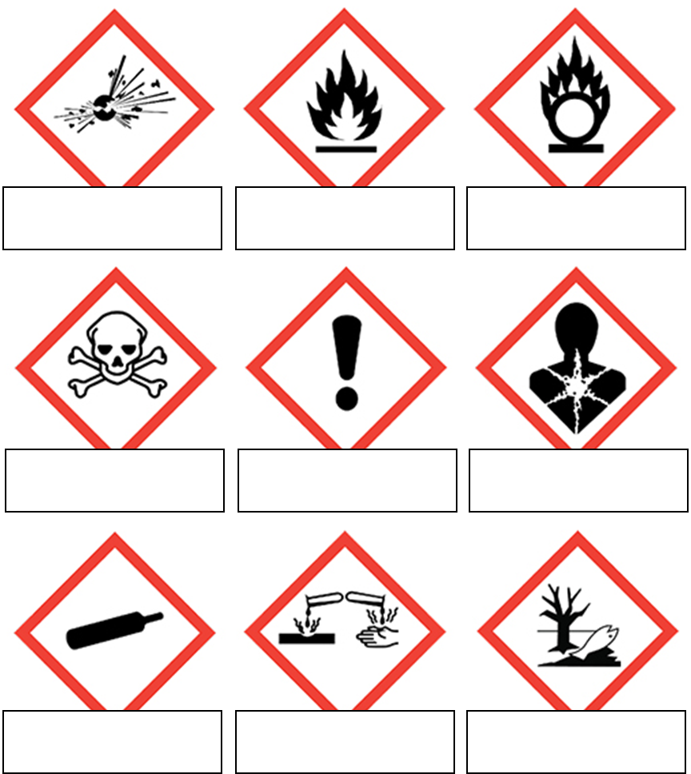

[ toxic – explosive – oxidising – corrosive – dangerous to the environment – flammable – long term health hazard – gas under pressure – caution ]

Task 2: Disposal of waste
Explain why it is necessary to dispose of waste chemicals in a safe and environmentally friendly way.

_____________________________________________________________________________________________________________________________________________________________________________________________________________________________________________________________________________________________________________________________________________________________________________

